

COMPANY PROFILE
2026



MASKAN COMPANY PROFILE 2026

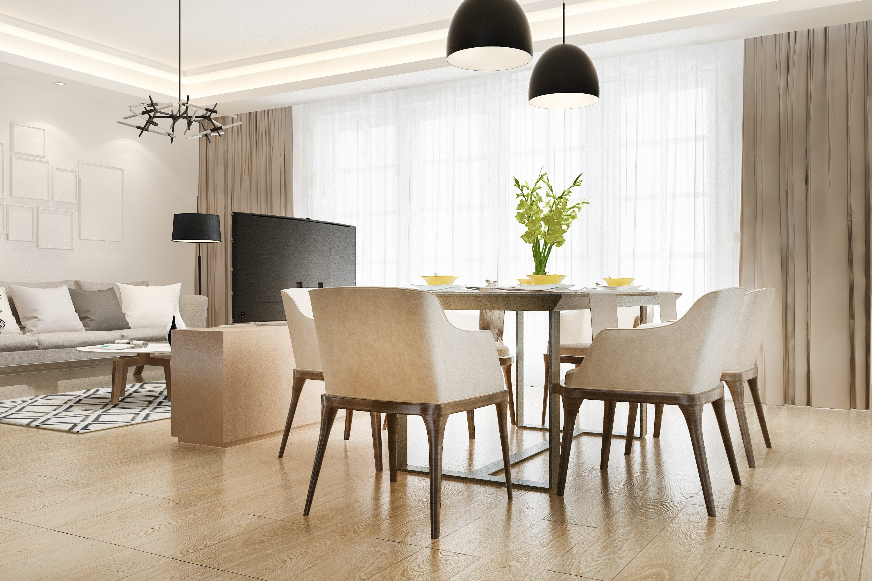

MASKAN COMPANY PROFILE 2026

INTRODUCTION

Maskan is a comprehensive finishing and contracting company
dedicated to delivering high-quality, well-executed spaces through precise planning, skilled execution, and attention to detail.

info@maskan-design.com

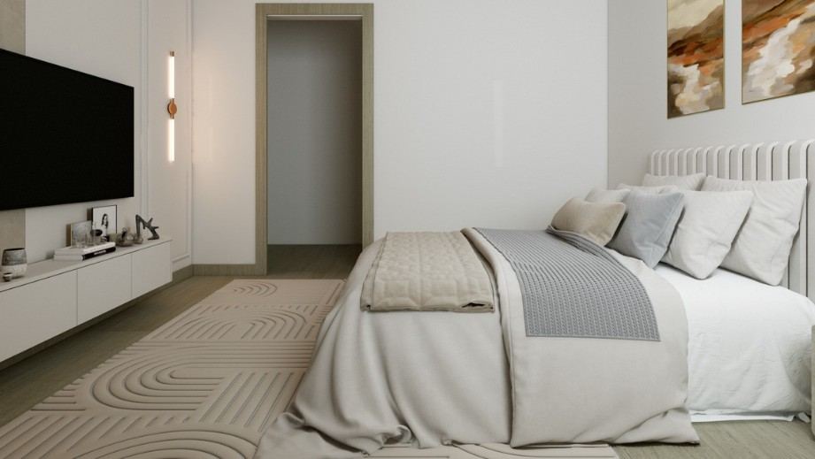
MASKAN COMPANY PROFILE 2026

Maskan provides a full range of integrated construction and finishing services, including:

Interior Finishing
2D & 3D Engineering Drawings Electrical Works
Plumbing Works Plastering (Mahara) Painting
Decorative Works Furnishing Exterior Finishing Incoming Works Public Drainage Landscap

info@maskan-design.com

Interior Finishing

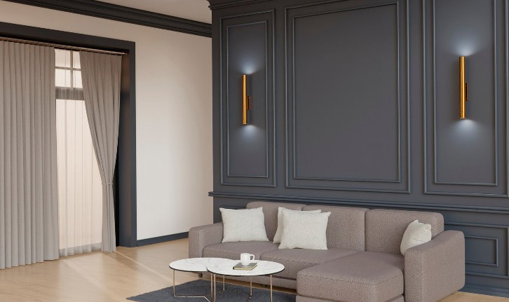

MASKAN COMPANY PROFILE 2026

info@maskan-design.com

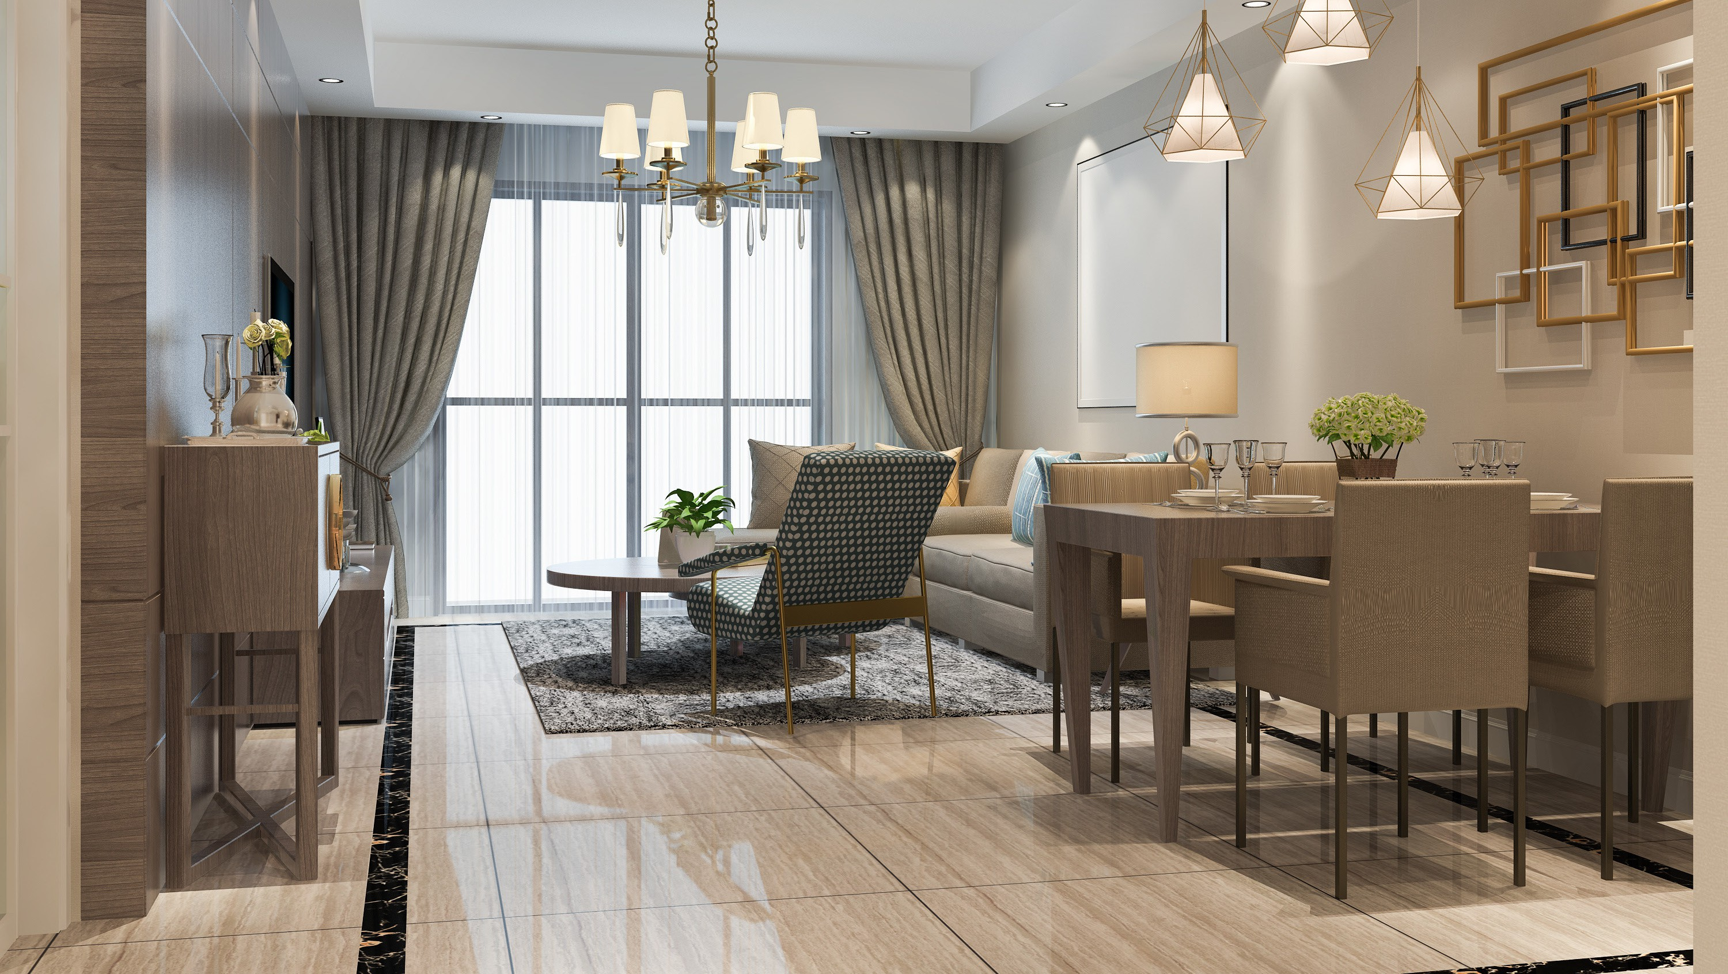
MASKAN COMPANY PROFILE 2026

info@maskan-design.com

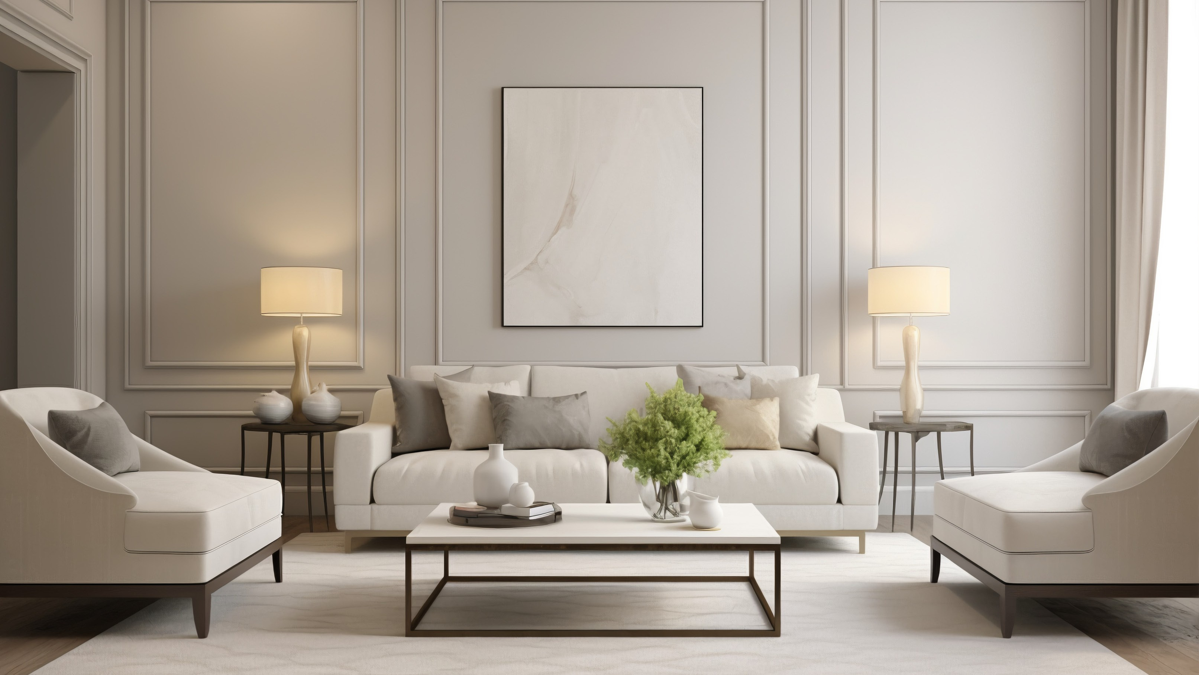

MASKAN COMPANY PROFILE 2026

info@maskan-design.com

2D Drawings

MASKAN COMPANY PROFILE 2026
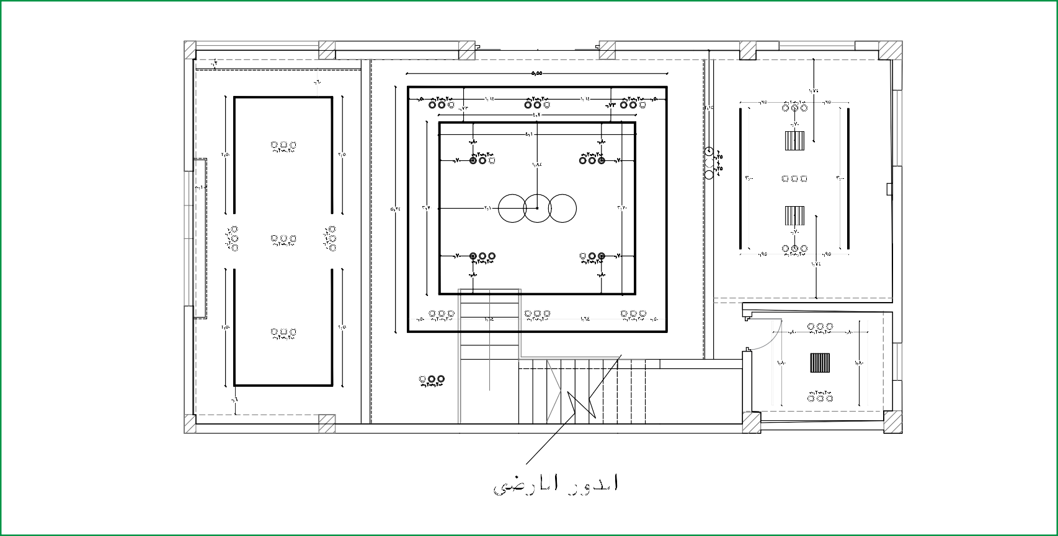

 info@maskan-design.com

MASKAN COMPANY PROFILE 2026
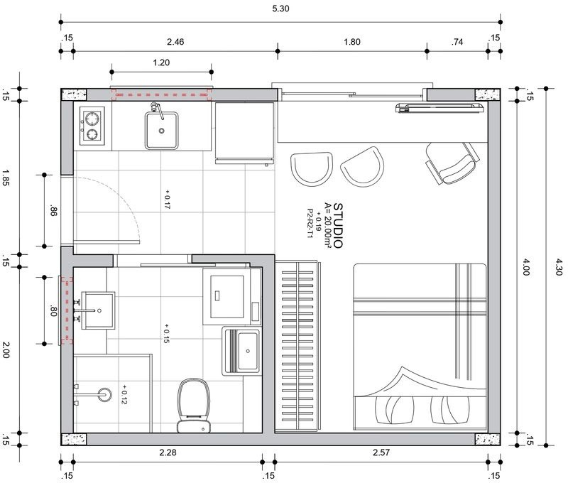

info@maskan-design.com

MASKAN COMPANY PROFILE 2026
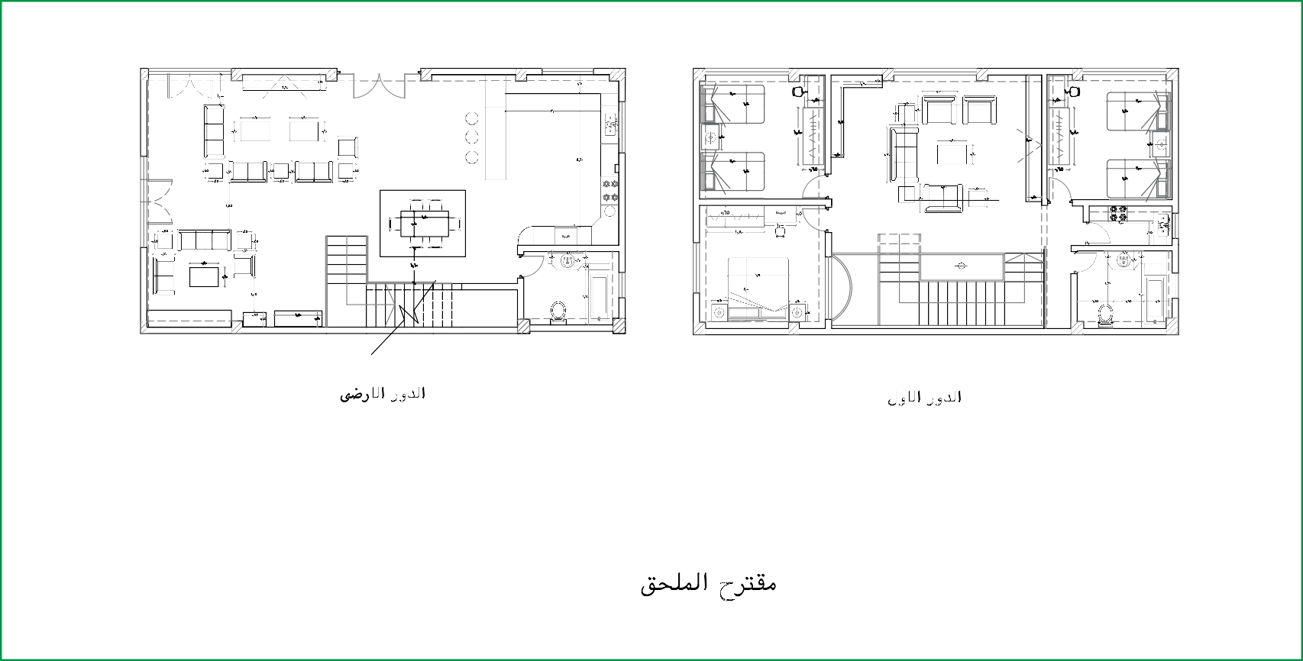

 info@maskan-design.com

3D Drawings

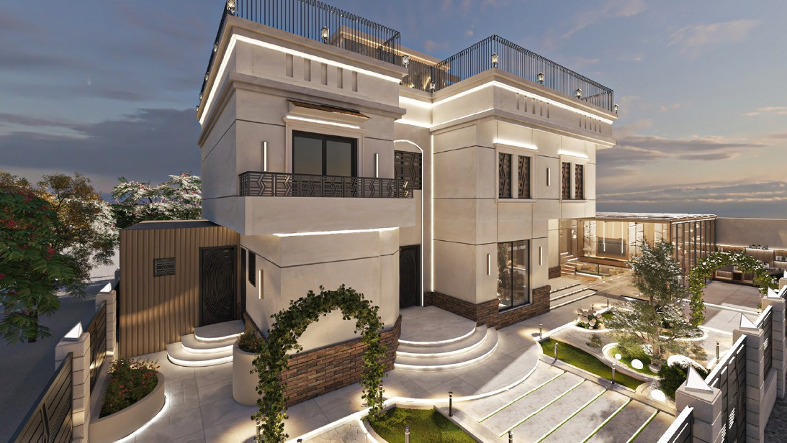

MASKAN COMPANY PROFILE 2026

info@maskan-design.com

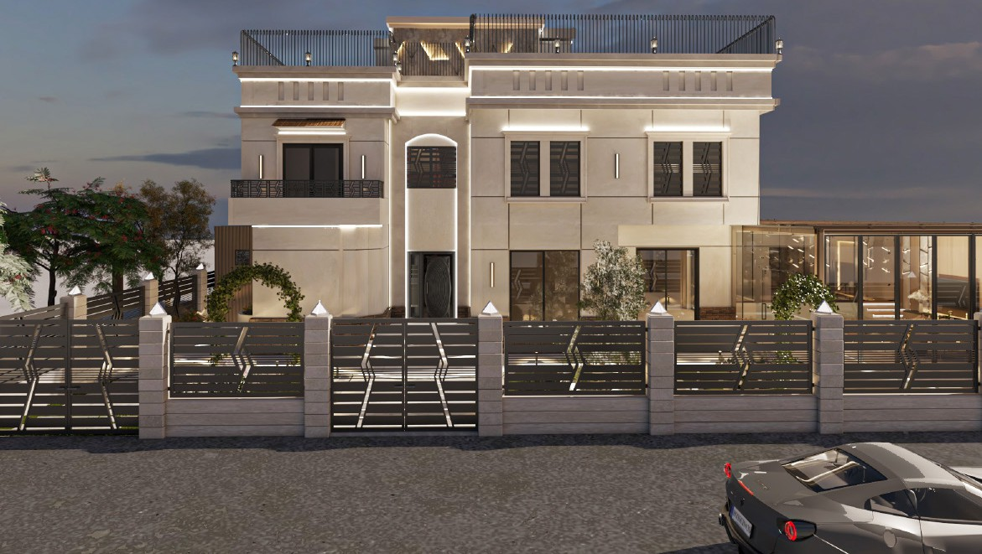
MASKAN COMPANY PROFILE 2026

info@maskan-design.com

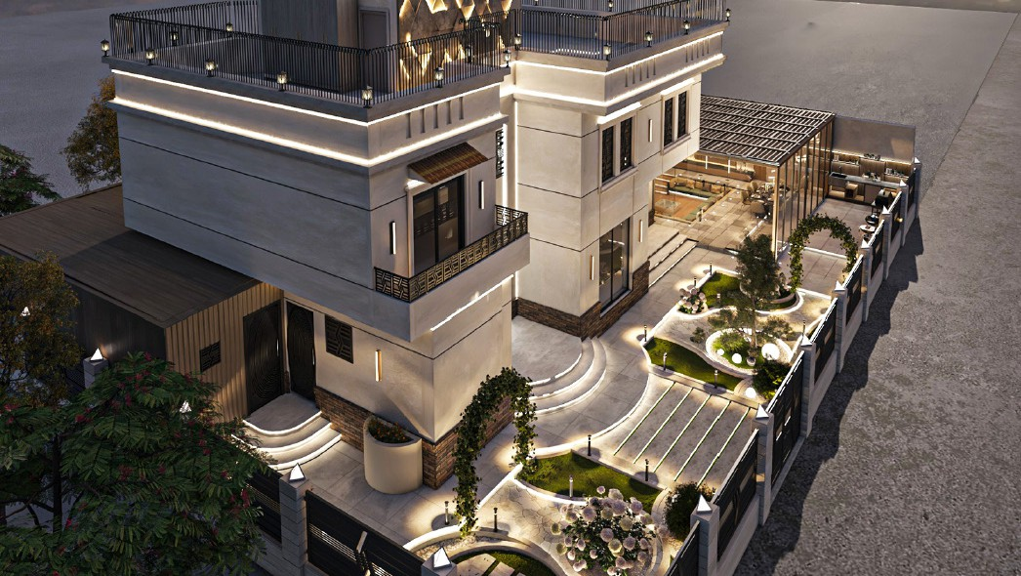
MASKAN COMPANY PROFILE 2026

info@maskan-design.com

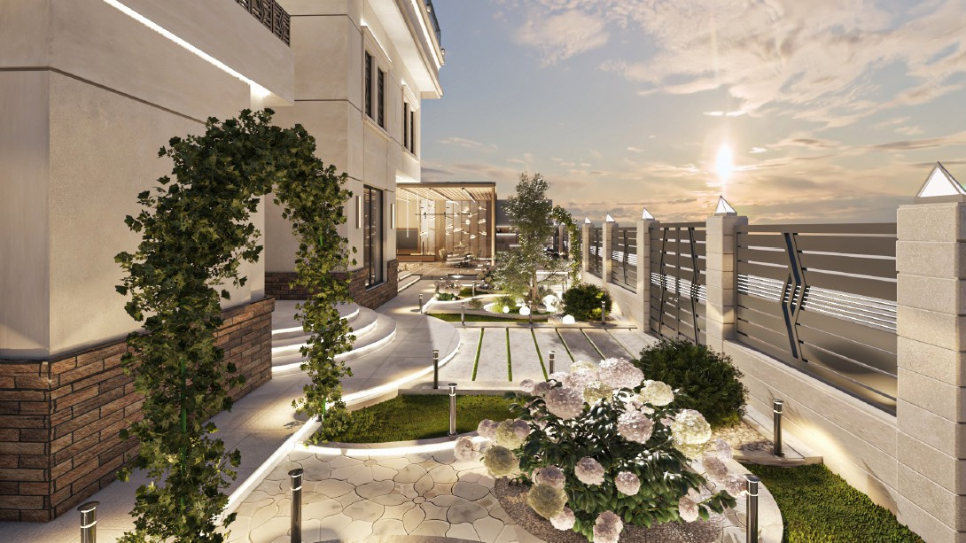
MASKAN COMPANY PROFILE 2026

info@maskan-design.com

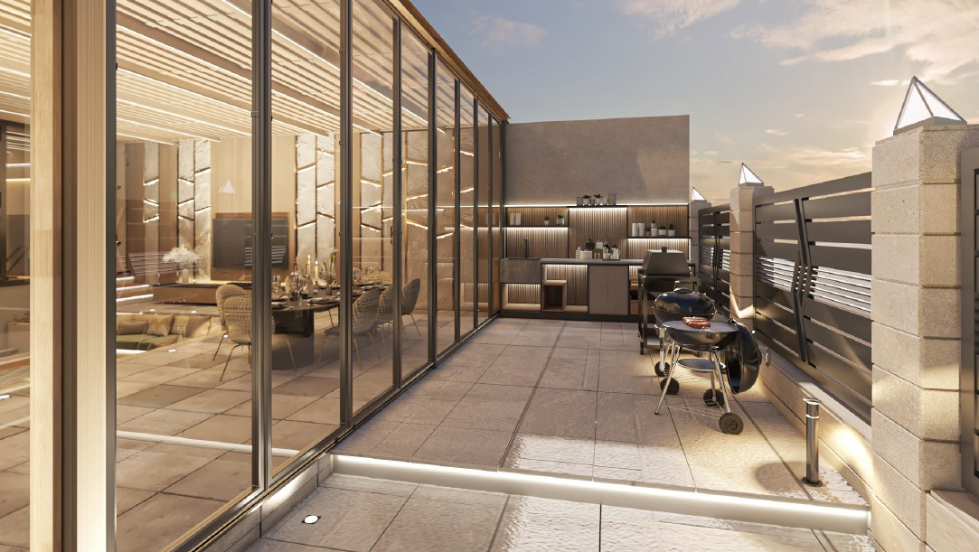
MASKAN COMPANY PROFILE 2026

info@maskan-design.com

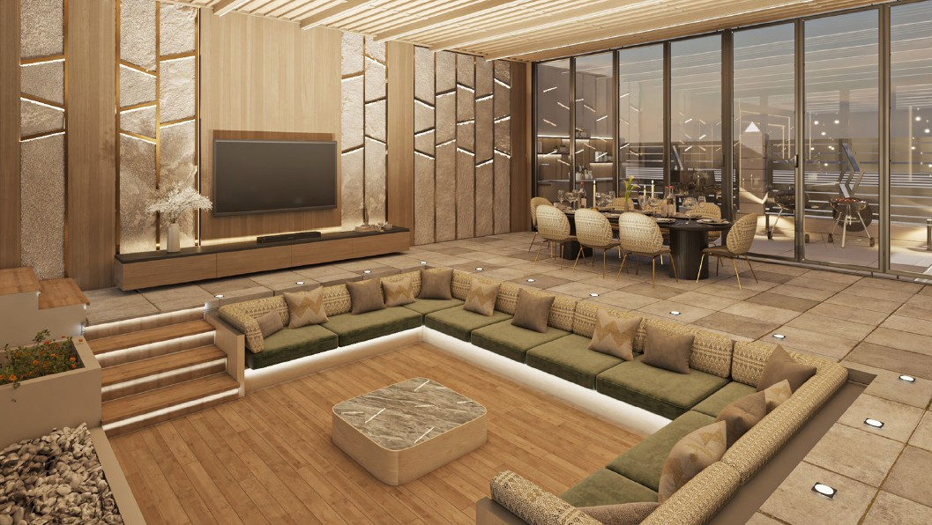
MASKAN COMPANY PROFILE 2026

info@maskan-design.com

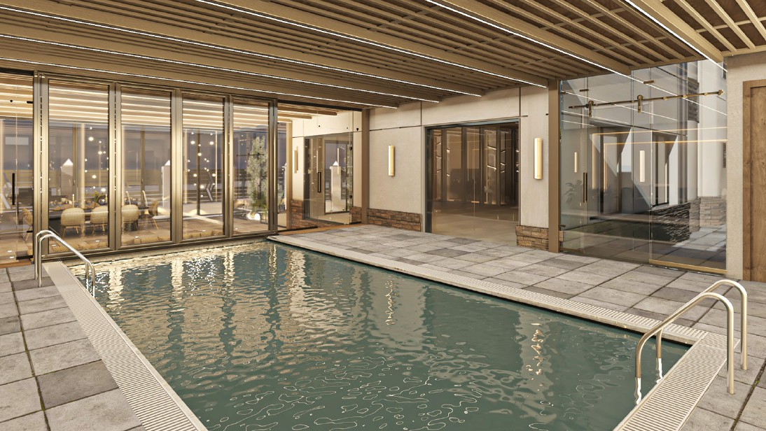
MASKAN COMPANY PROFILE 2026

info@maskan-design.com

Electrical Works

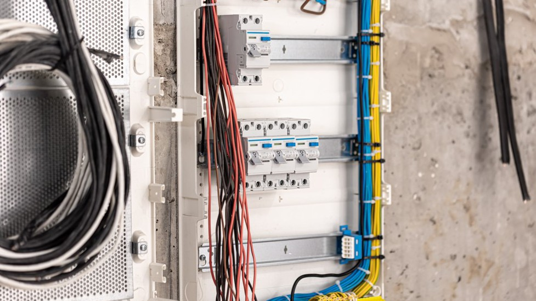
MASKAN COMPANY PROFILE 2026

info@maskan-design.com


MASKAN COMPANY PROFILE 2026

info@maskan-design.com

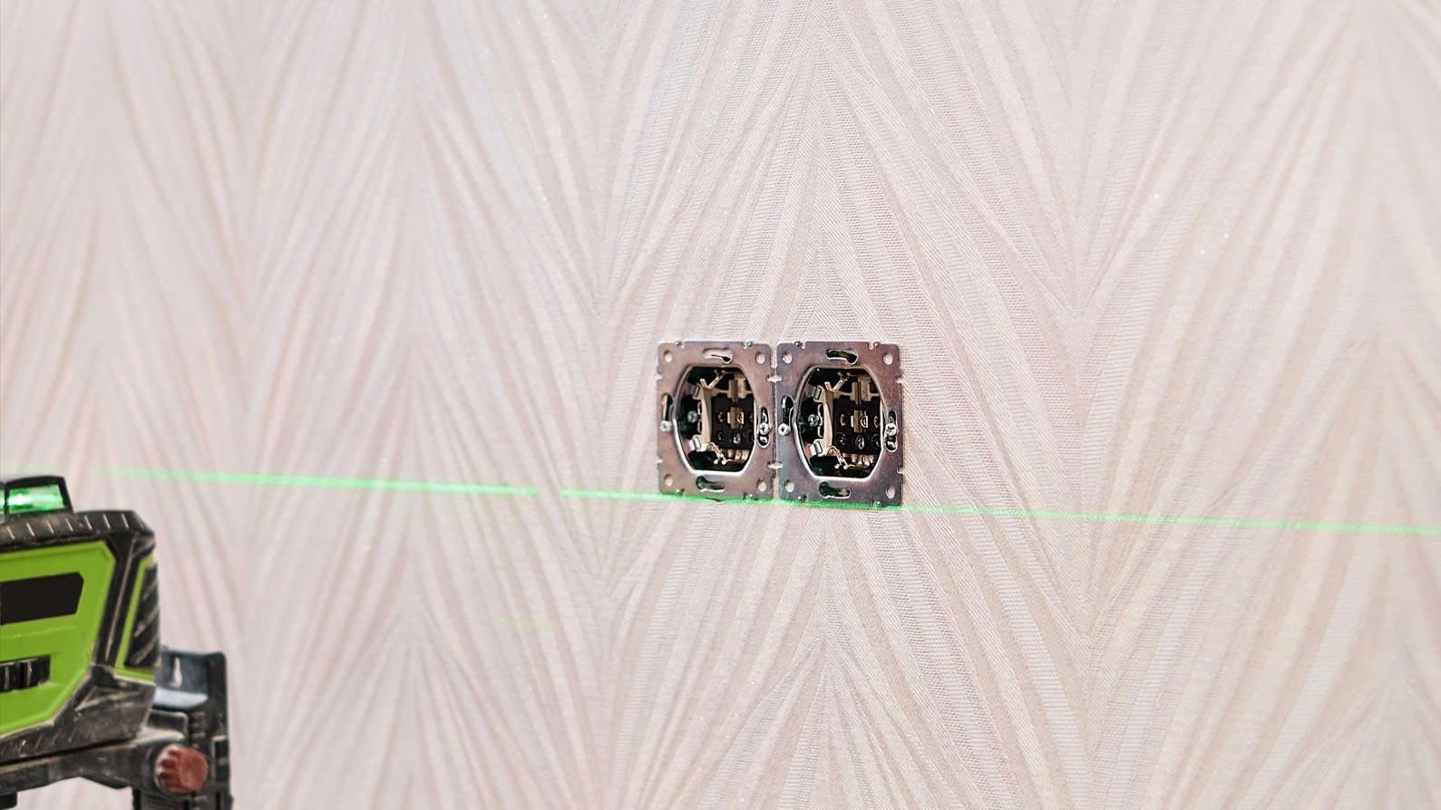
MASKAN COMPANY PROFILE 2026

info@maskan-design.com

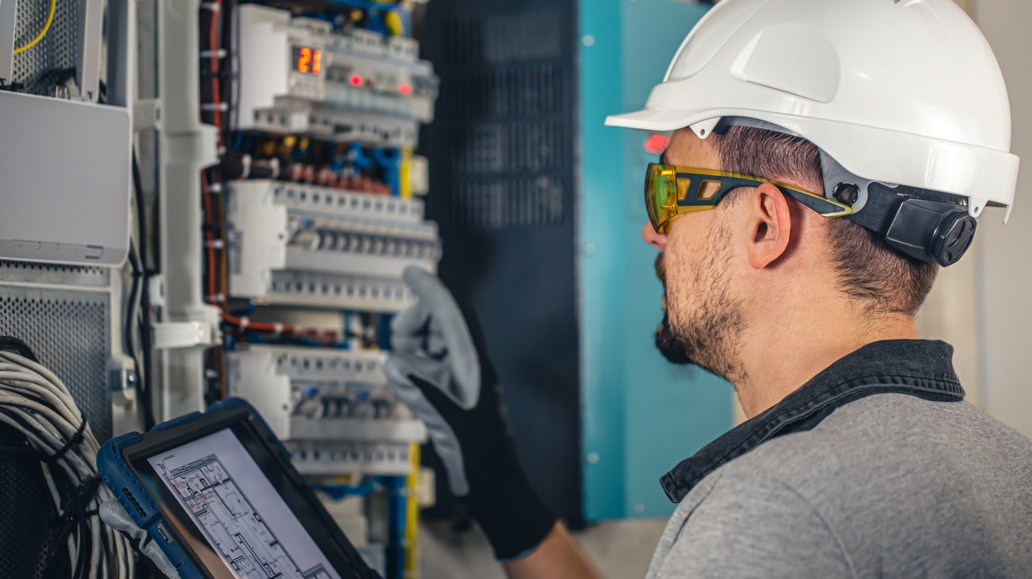

MASKAN COMPANY PROFILE 2026

info@maskan-design.com

Plumbing Works

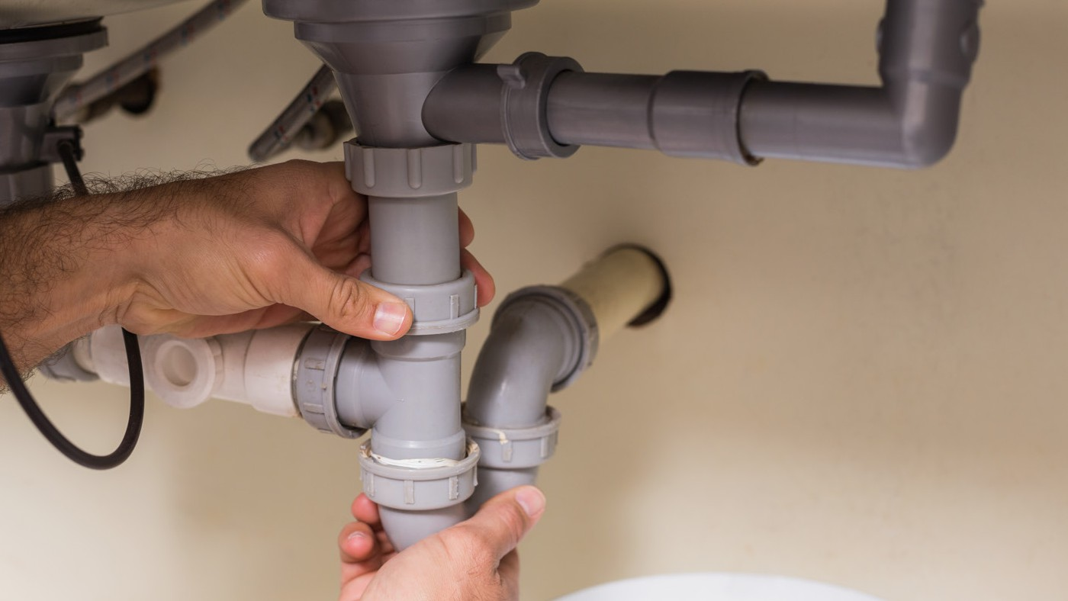
MASKAN COMPANY PROFILE 2026

info@maskan-design.com


MASKAN COMPANY PROFILE 2026

info@maskan-design.com



MASKAN COMPANY PROFILE 2026

info@maskan-design.com

Plastering (Mahara)

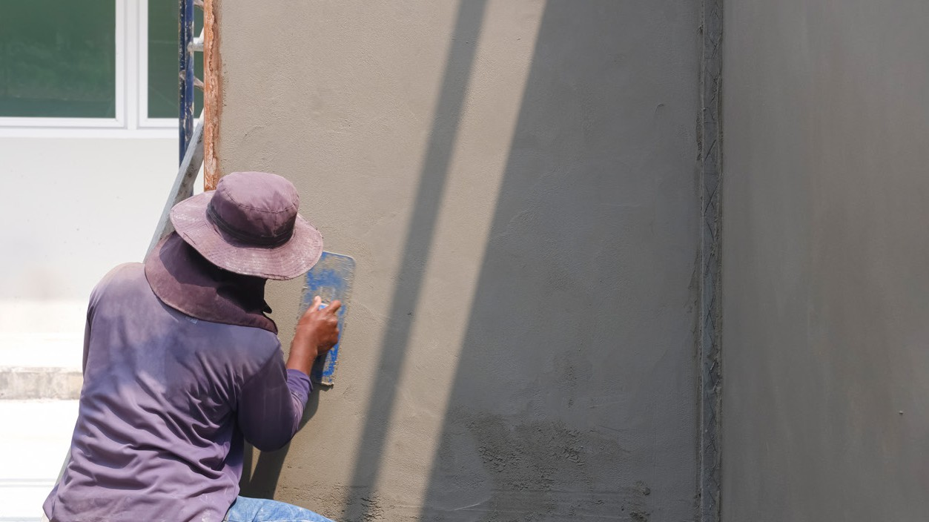

MASKAN COMPANY PROFILE 2026

info@maskan-design.com

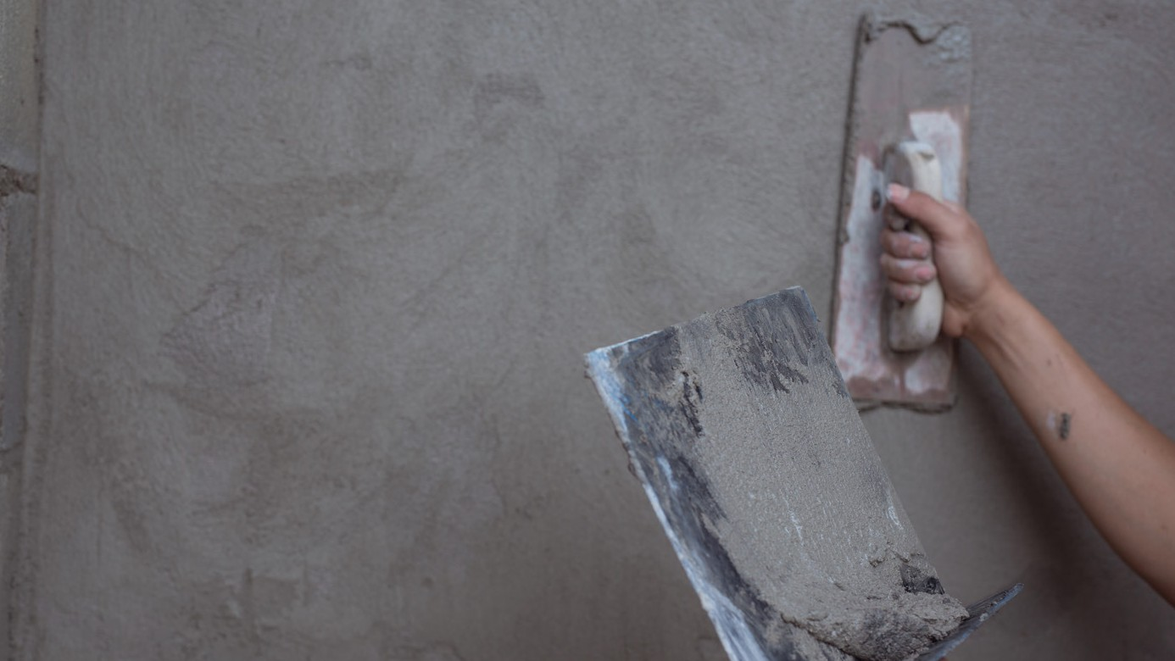
MASKAN COMPANY PROFILE 2026

info@maskan-design.com

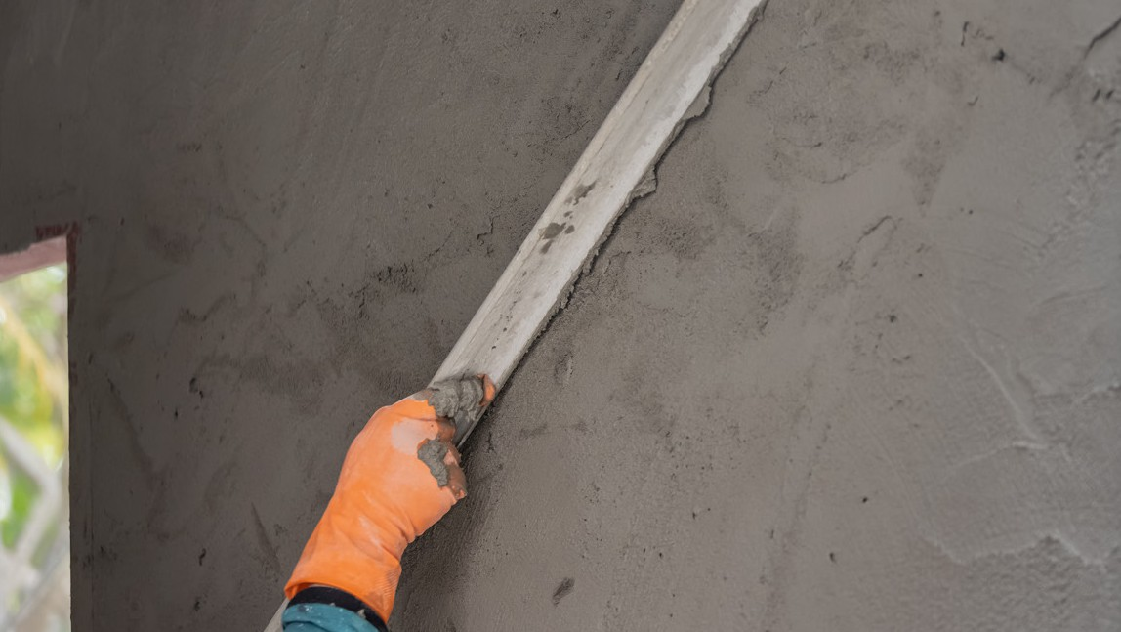
MASKAN COMPANY PROFILE 2026

info@maskan-design.com

Painting

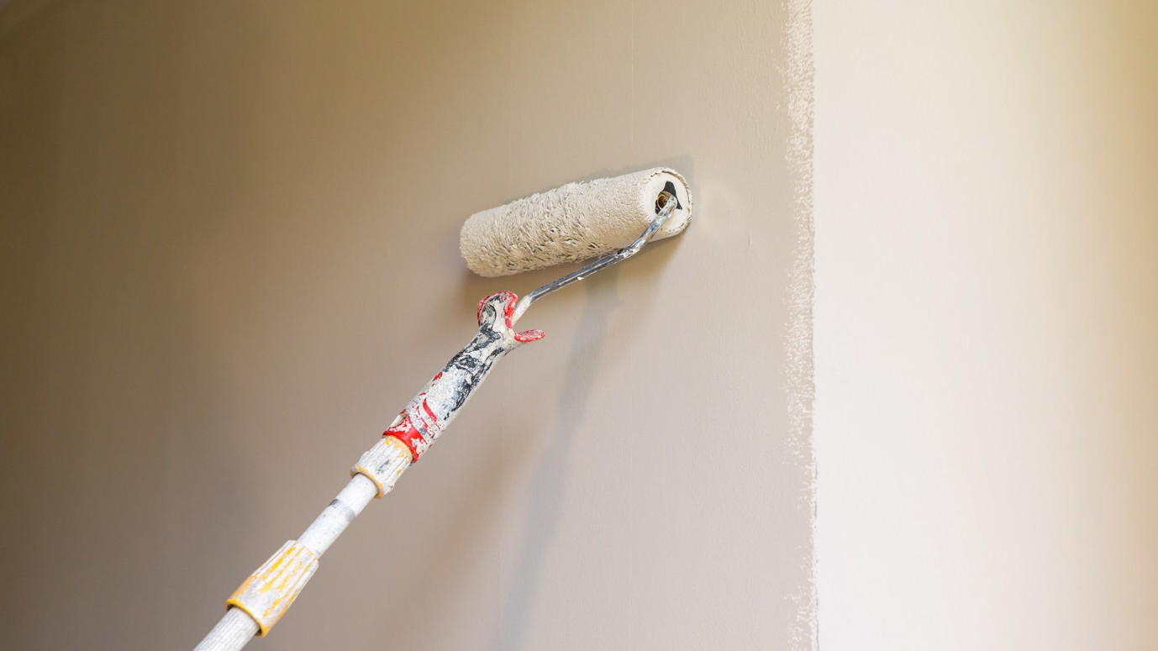
MASKAN COMPANY PROFILE 2026

info@maskan-design.com

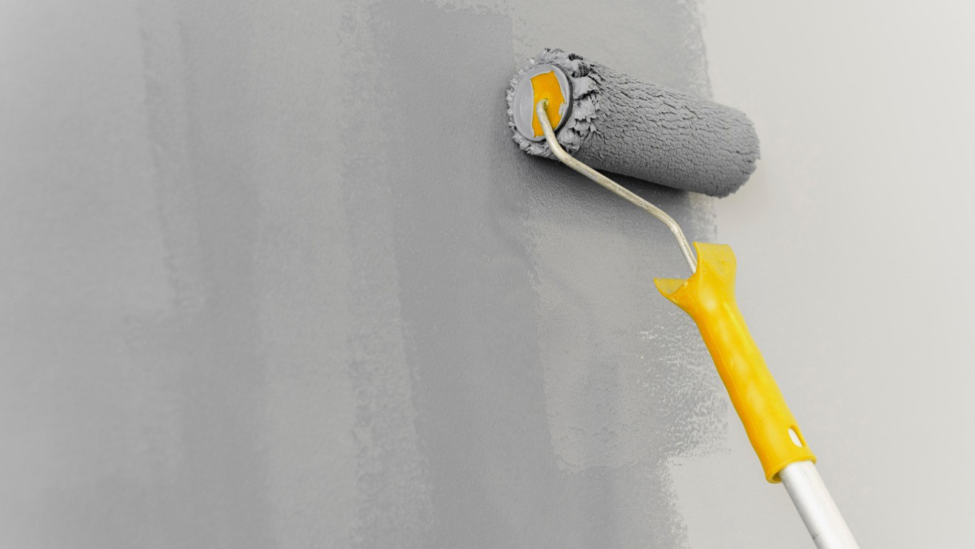
MASKAN COMPANY PROFILE 2026

info@maskan-design.com

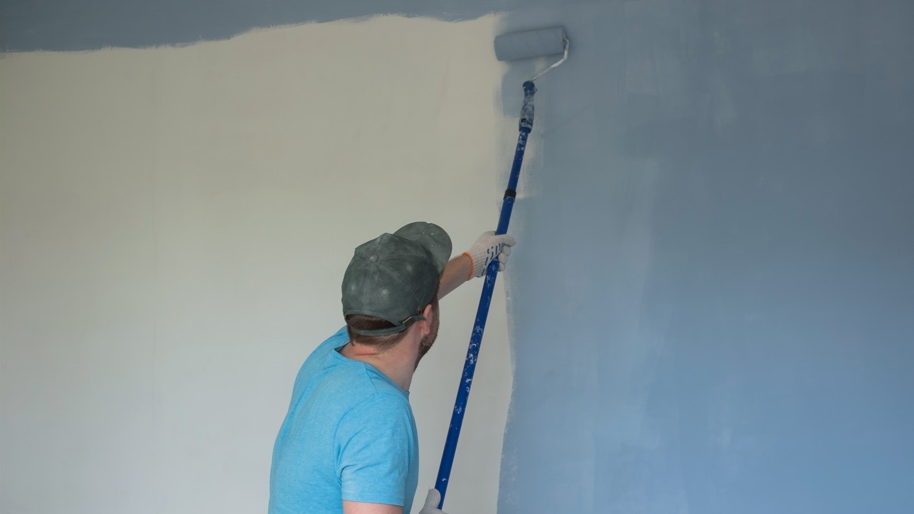
MASKAN COMPANY PROFILE 2026

info@maskan-design.com


MASKAN COMPANY PROFILE 2026

info@maskan-design.com

Furnishing

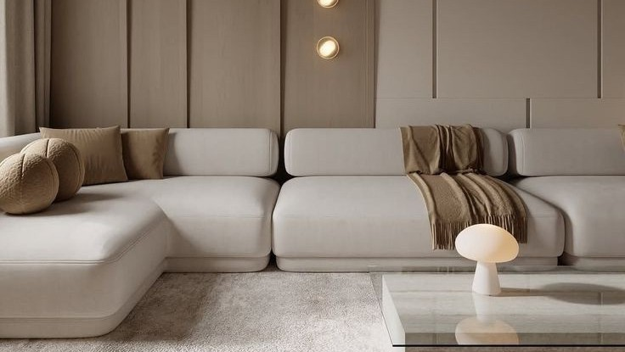
MASKAN COMPANY PROFILE 2026

info@maskan-design.com

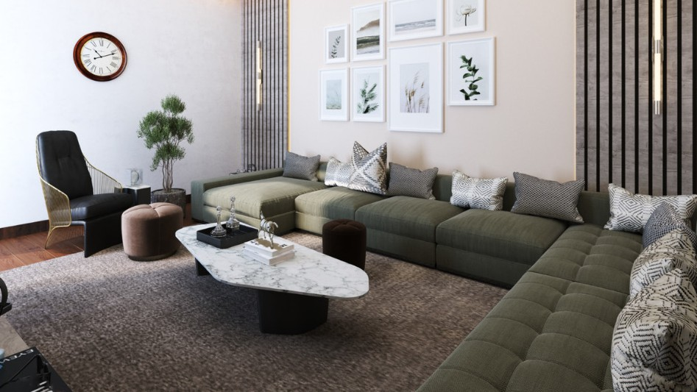
MASKAN COMPANY PROFILE 2026

info@maskan-design.com

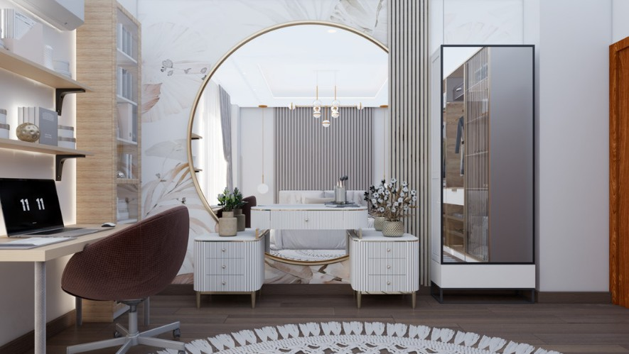
MASKAN COMPANY PROFILE 2026

info@maskan-design.com

Exterior Finishing

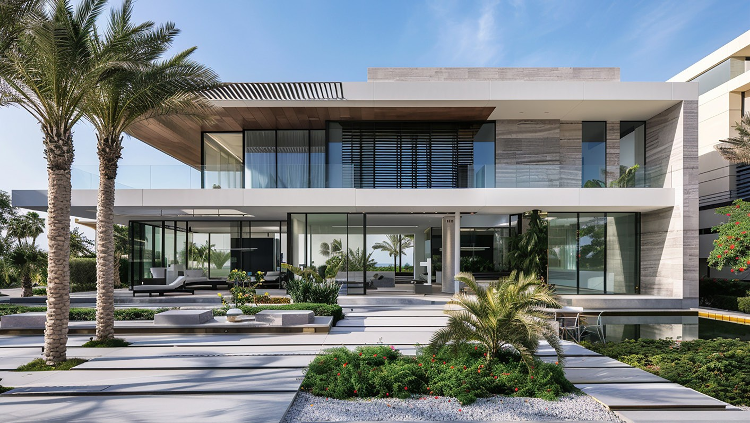

MASKAN COMPANY PROFILE 2026

info@maskan-design.com

MASKAN COMPANY PROFILE 2026

info@maskan-design.com

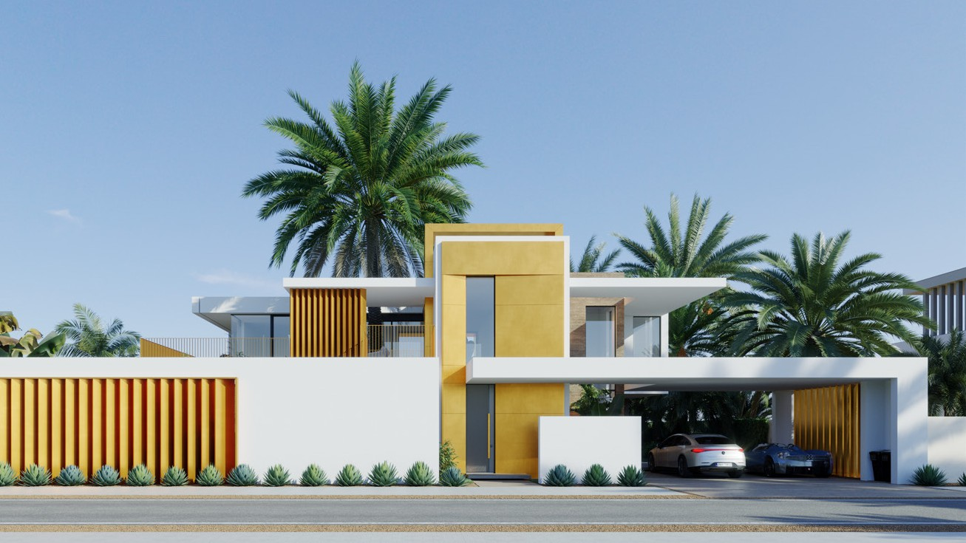
MASKAN COMPANY PROFILE 2026

info@maskan-design.com


MASKAN COMPANY PROFILE 2026

info@maskan-design.com



Public Drainage

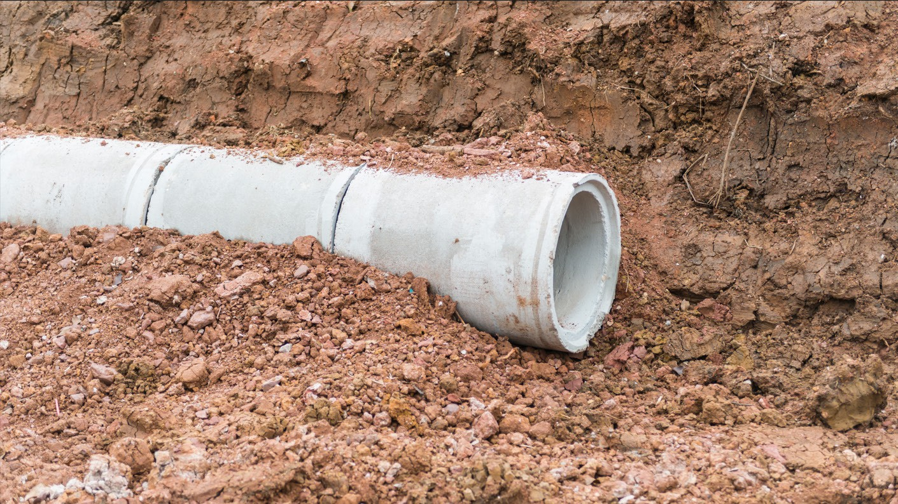
MASKAN COMPANY PROFILE 2026

info@maskan-design.com

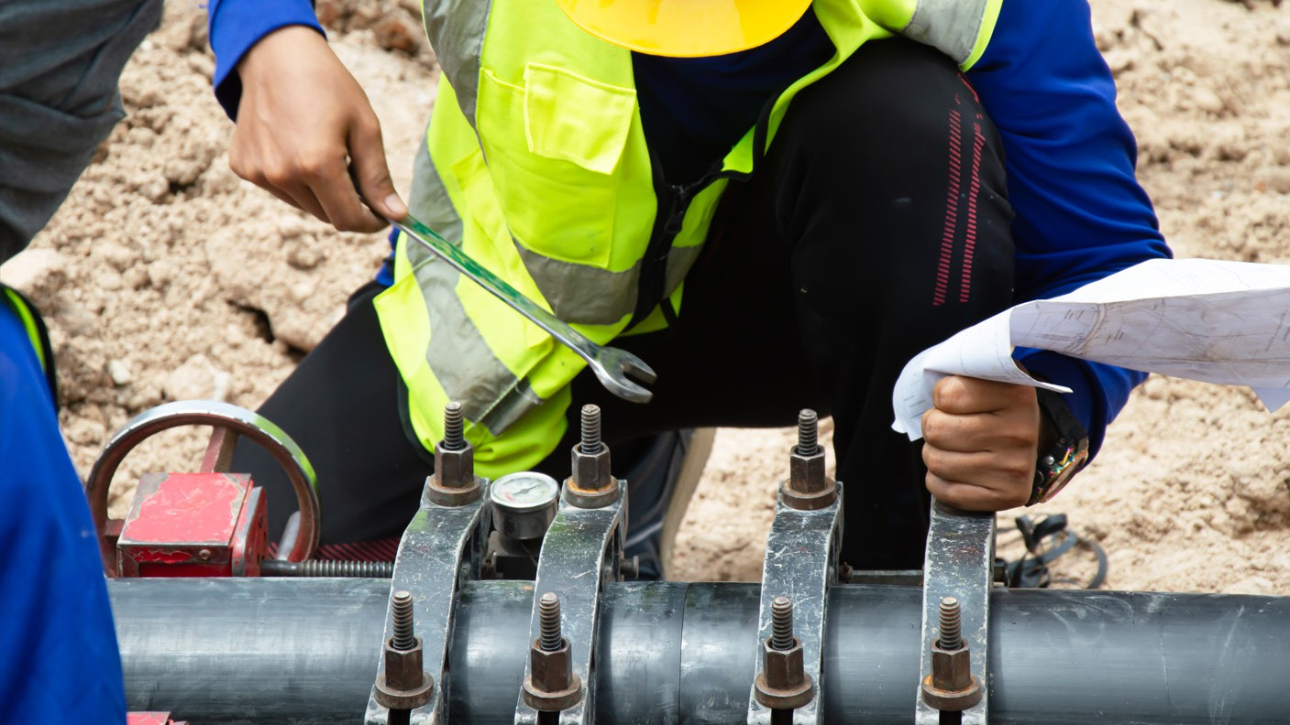
MASKAN COMPANY PROFILE 2026

info@maskan-design.com

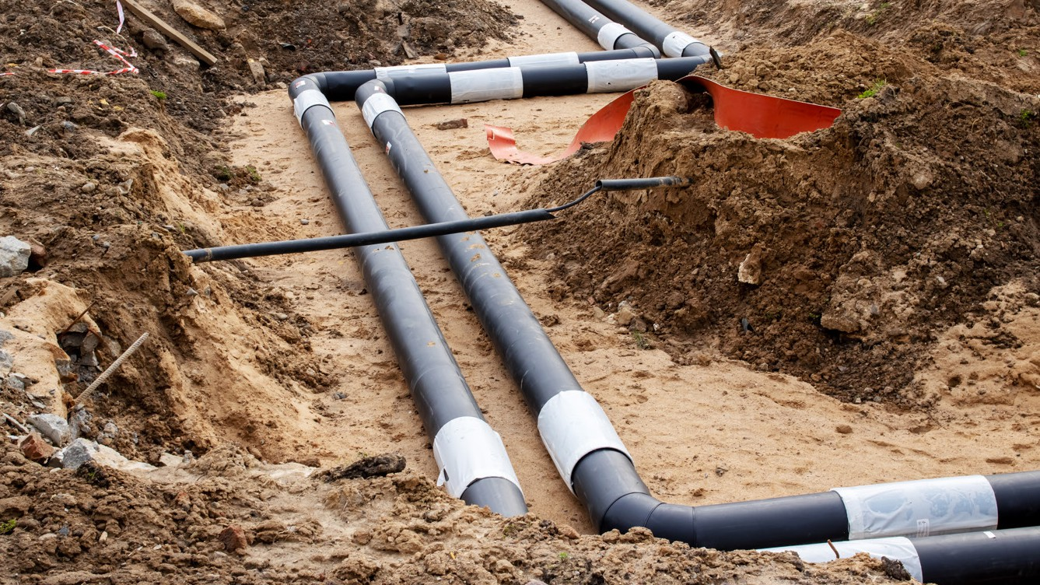
MASKAN COMPANY PROFILE 2026

info@maskan-design.com

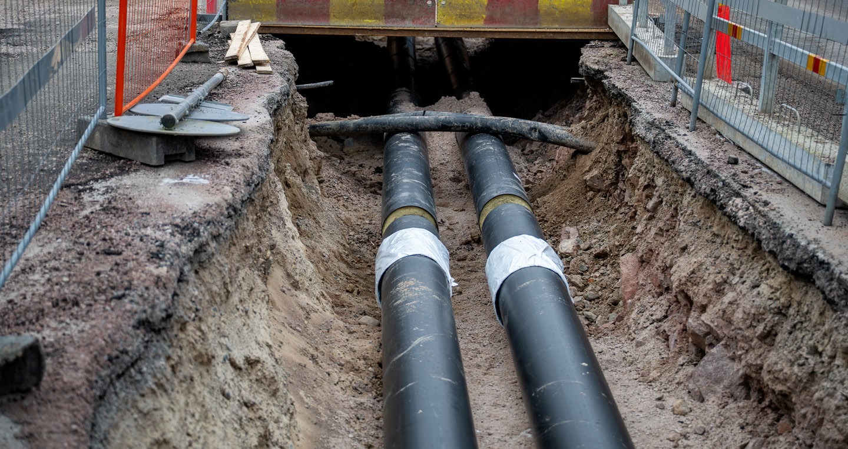
MASKAN COMPANY PROFILE 2026

info@maskan-design.com

Landscap

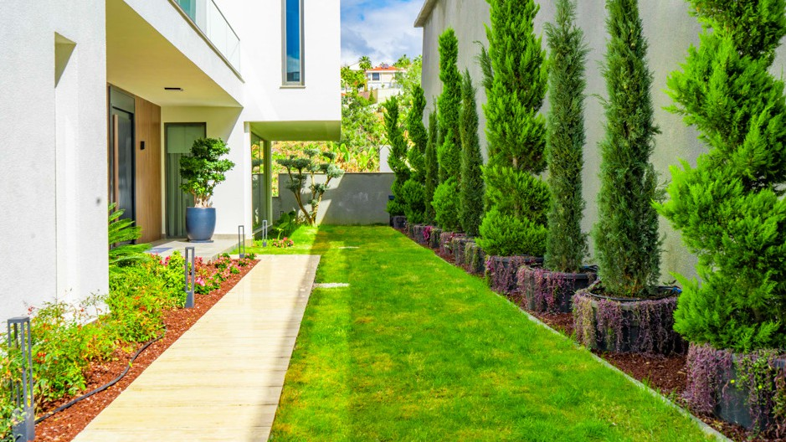
MASKAN COMPANY PROFILE 2026

info@maskan-design.com

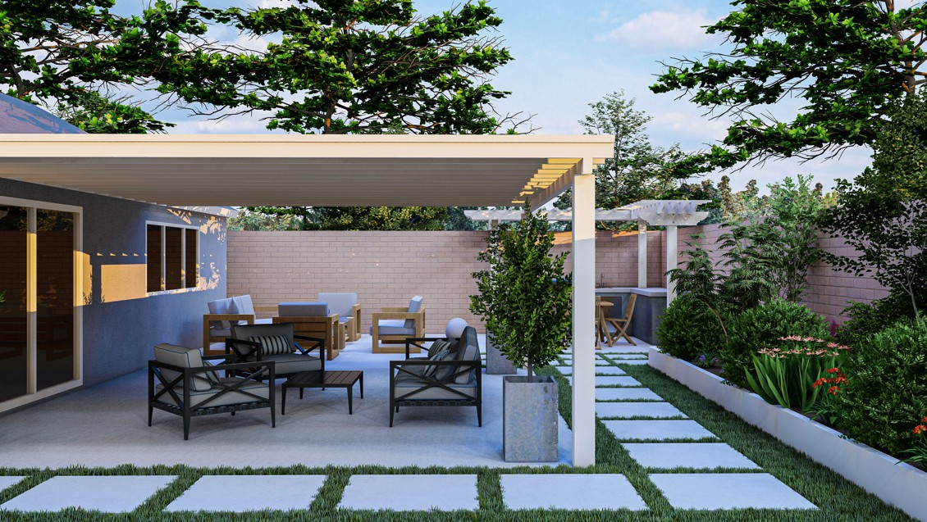
MASKAN COMPANY PROFILE 2026

info@maskan-design.com

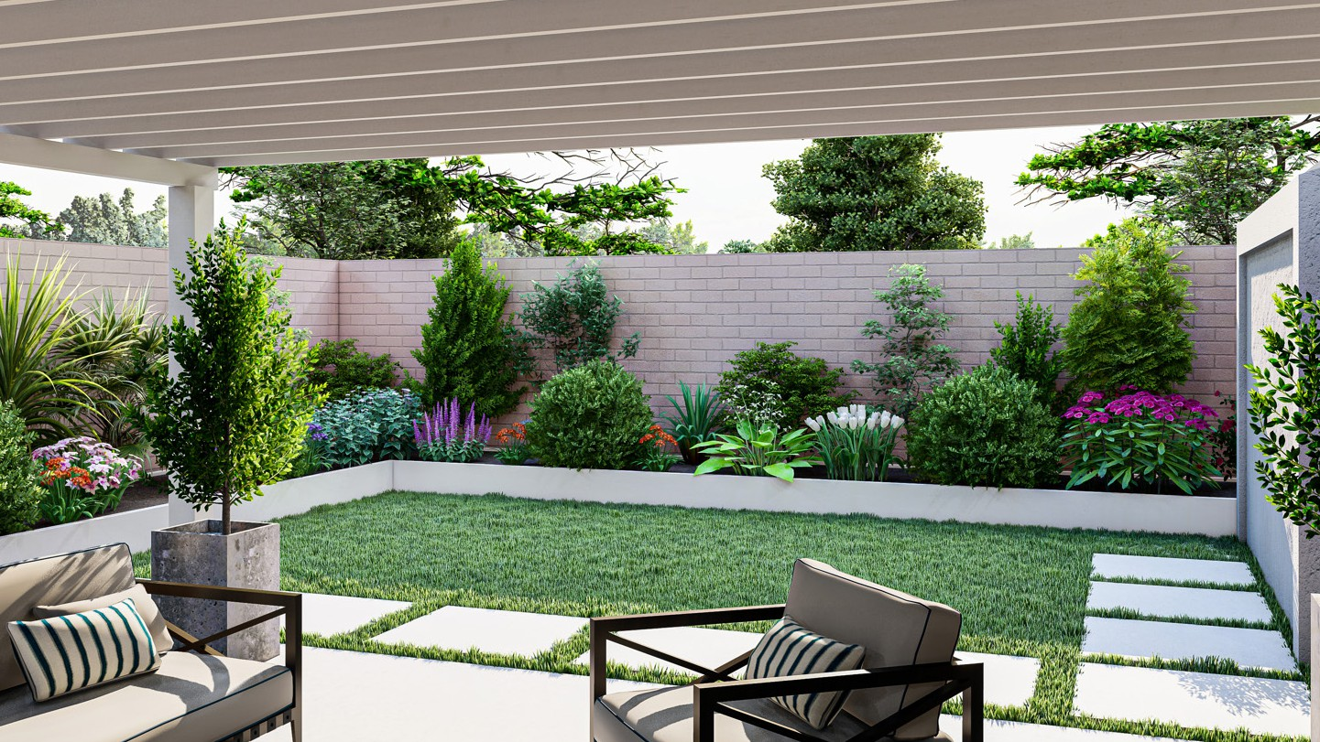

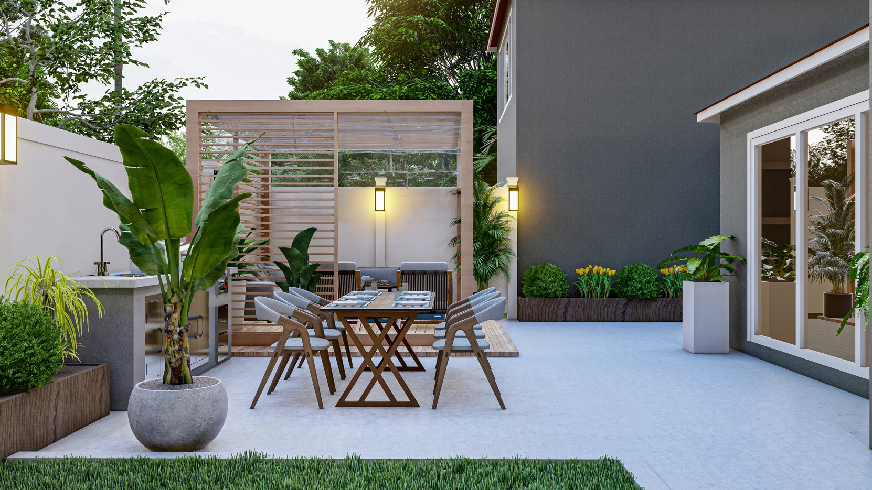


Contact Us
support@maskan-design.com info@maskan-design.com

THANKS
FOR WATCHING

